**MODERN DATABASE MANAGEMENT SYSTEM**

**ROLL NO:245229152**

**BASIC SQL QURIES OF DDL & DML**

**Creating book table:**

CREATE TABLE Books (

book_id INT PRIMARY KEY,

title VARCHAR(100),

author_id INT,

published_year INT

);

**Creating author table:**

CREATE TABLE Authors (

author_id INT PRIMARY KEY,

author_name VARCHAR(100)

);

**Altering table :**

ALTER TABLE Books

ADD publisher VARCHAR(100);

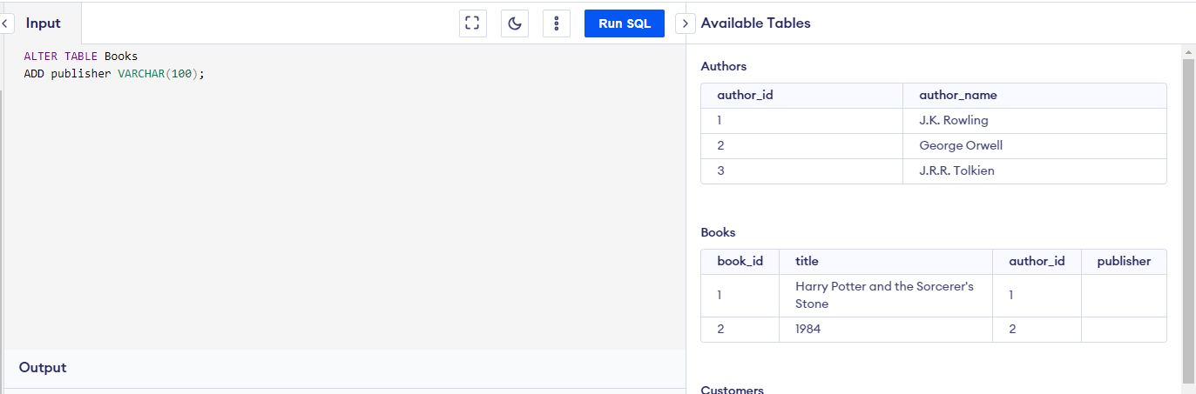

**DROP:**

DROP table Books

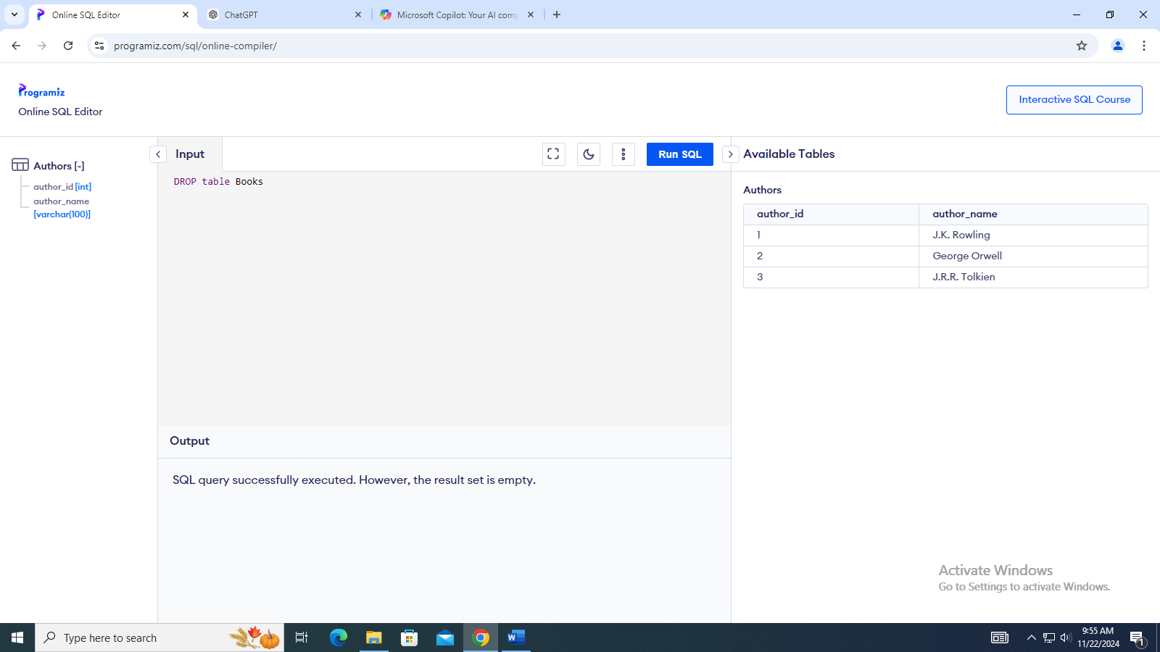

**DML**

**Inserting books records and author records:**

INSERT INTO Authors (author_id, author_name)

VALUES (1, 'J.K. Rowling'),

(2, 'George Orwell'),

(3, 'J.R.R. Tolkien');

INSERT INTO Authors (author_id, author_name)

VALUES (1, 'J.K. Rowling'),

(2, 'George Orwell'),

(3, 'J.R.R. Tolkien');

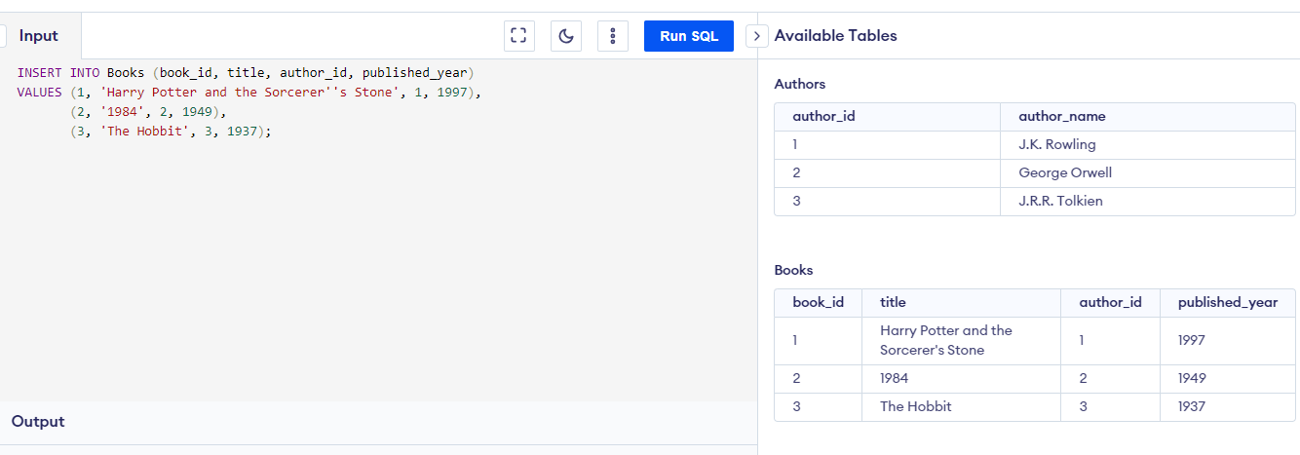

**Select commands:**

SELECT * FROM Books;

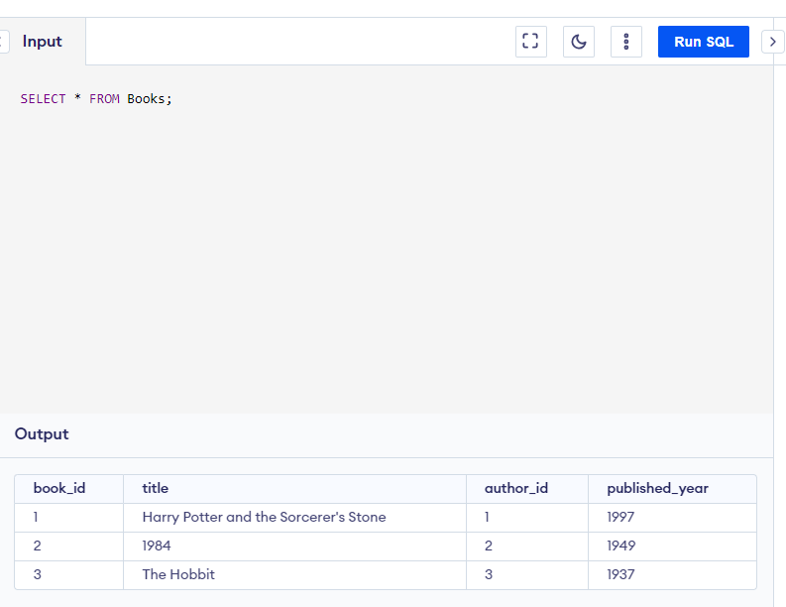

SELECT title, published_year FROM Books;

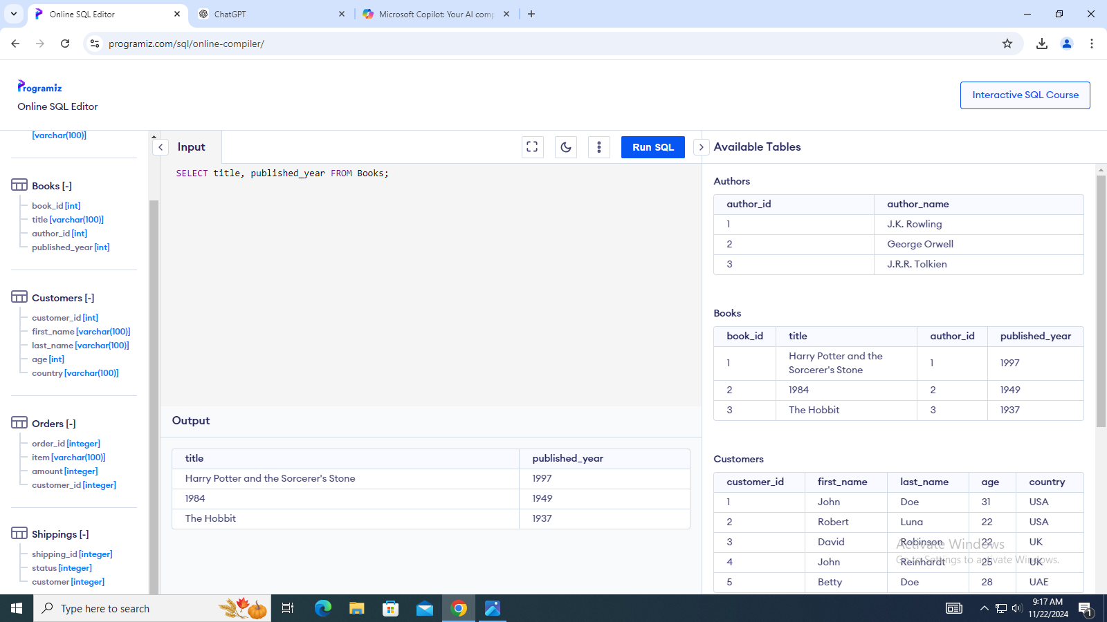

SELECT * FROM Books

WHERE book_id = 1;

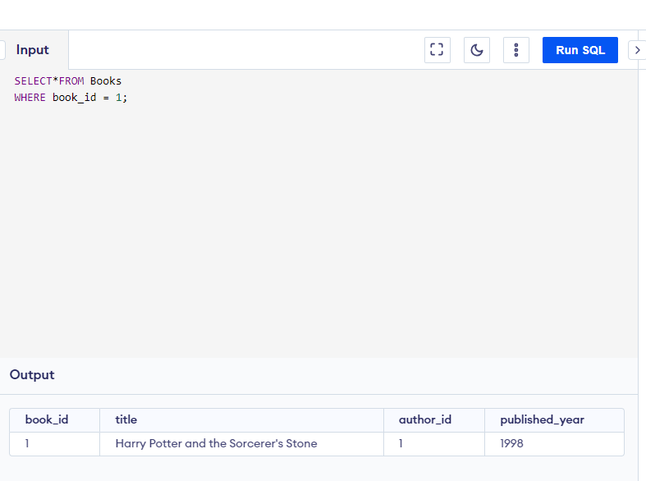

**Update commands:**

UPDATE Books

SET published_year = 1998

WHERE book_id = 1;

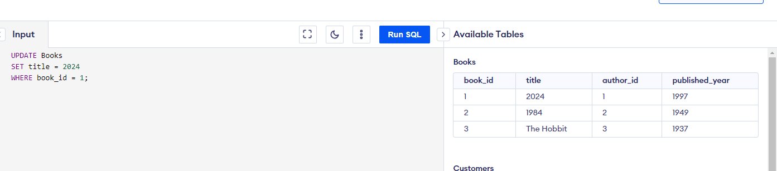

**Delete commands:**

DELETE FROM Books

WHERE book_id = 3;

